The dataset **opl_female.csv** contains data on female competitors for various powerlifting tournaments. These tournaments consist of 3 different powerlifting events which are the bench, squat, and deadlift events all measured in Kilograms. The motivation of this data analysis is to explore the relationship between bench and squat weights (in Kilograms) to gain insights into the performance patterns of the competitors. For this activity, we will specifically focus on weights from 25-year-old female competitors.

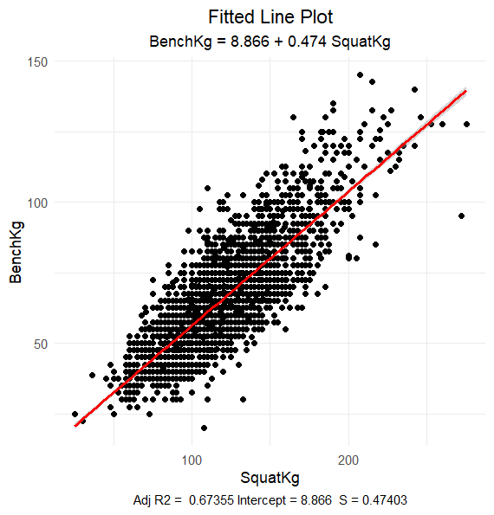

1. What is the explanatory variable in this situation? What is the response variable? What type are both variables? What are the units?

Explanatory Variable: Squat Weight - Kilograms  
Response: Bench Weight - Kilograms  
**Both variables are Numerical**

1. What does each point in the scatterplot represent?

Each dot represents a 25-year-old female competitor.

1. Report the least squares regression equation for predicting run time from bike time.
$$\hat{BenchKg}= 8.866+0.474(SquatKg)$$

2. Suppose that you were interested in using this regression model to predict the run time for Sarah True, the USA Olympic Triathlete. What assumption about your data would you need to make?

You need to assume that the relationship between run time and bike time is the same for United States women (like Sarah True) as it is for Canadian women (which is what the regression model is based on).

1. Sara Crews had a 120.0 squat weight. What is her predicted bench weight? Regardless of your answer to the previous question, continue to use the equation from question 3.

$$\hat{BenchKg}= 8.866+0.474\left(120.0\right)=65.746 weight in Kg$$

1. Crews’ bench weight was 65.00 kilograms. How far off was the model prediction? Explain why we might see this observation.

65.0 Kg – 65.746 Kg = -0.746 Kg.  
Answers may vary for the explanation.   
Sample: The running segment might be her best event; therefore, she is faster than expected

1. Interpret the slope of the model in the context of the application. Be sure to be mindful of the units.

For every 1 kilogram of weight for Squat, the Bench weight is expected to increase by 0.474 kilograms

1. Interpret the intercept of the model in the context of the application.

When the Squat weight is zero, the expected Bench weight is 8.866 kilograms.

1. Is the intercept interpretation meaningful? Explain.

No, this is not a meaningful interpretation.   
  
Neither a Bike Time of 0 minutes or a Run Time of -72.36 minutes is possible.

1. What percent of variation in Run Times is explained by the model using Bike Time? What is the sample correlation?

R2 = 67.4%

1. Based on your comprehensive analysis, describe the relationship between bench weights and squat weights using multiple pieces of information from your findings.

Solutions may vary, but, a solution should incorporate a description of the scatterplot supplemented with the results from the regression model. For example,Lake Placid Canadian Women’s Ironman Triathlon run and bike times have a clear positive relationship with no extreme outliers. This relationship seems linear and fairly strong (resulting in an R-Squared of 65.5%).

1. Given the structure of the Ironman race, where participants complete a 2.4-mile swim, a 112-mile bicycle ride, and a marathon 26.22-mile run in that order, explain how this information can be used to explore the relationship between the average speed at which a triathlete completes the bike and run portions of the race.

Answers can vary. One possible solution is to convert bike and run events into speeds (e.g., miles per hour). Other solutions could be based on pace (e.g., “X minute mile”)

1. If you have the technology to do so, fit the least squares regression model predicting running speed from biking speed. Record the equation and interpret the slope coefficient in the context of the application.

Answers are dependent on the choice made in the previous question. Here is sample output when converting to speed in miles per hour.